**LAB REPORT #3** Name: Owais Rao

**Experiment No.3** Roll No.:22L-7638

Class: BSEE-1A2

**Introduction:-**

**In this experiment, we learnt about basic data types, variable declaration and basic operators.** The ‘type’ of a variable determines what kinds of values it may take on. An ‘operator’ computes new values out of old ones. An ‘expression’ consists of variables, constants, and operators combined to perform some useful computation. A declaration consists of the type, the name of the variable, and a terminating semicolon. Whenever a variable is defined in C++, the compiler allocates some memory for that variable based on the data type with which it is declared. Every data type requires a different amount of memory.

**Objective:-**

* To get familiar with arithmetic operators
* To understand how to use basic arithmetic operators in C++

**Procedure:-**

With the help of lab manual, I was able to write codes for given exercises. They are as follows with their outputs:-

**Exercise 1:-**

#include <iostream>

using namespace std;

void main()

{

int x, y, z;

double w, t;

x = 17;

y = 15;

x = x + y / 4;

z = x % 3 + 4;

w = 17 / 3 + 6.5;

t = x / 4.0 + 15 % 4 - 3.5;

cout<< endl << x << endl << y << endl << z << endl << w << endl << t << endl;

}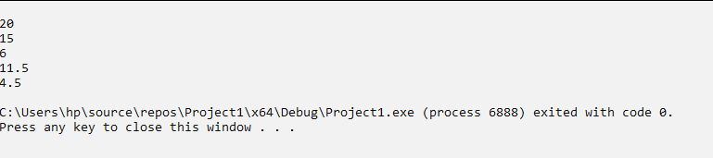

**Exercise 2:-**

#include <iostream>

using namespace std;

void main()

{

int n, a, b, c, d, e;

cout << "\nEnter 5-digit Integer: ";

cin >> n;

a = n / 10000;

n = n - a * 10000;

b = n / 1000;

n = n - b * 1000;

c = n / 100;

n = n - c * 100;

d = n / 10;

n = n - d * 10;

e = n;

cout << "\nReversed Number is " << e << d << c << b << a << endl;

}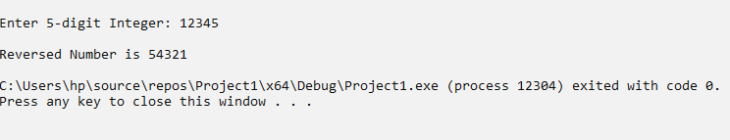

**Exercise 3:-**

#include <iostream>

using namespace std;

void main()

{

char A, B, C, D;

cout << "\nEnter Character: ";

cin >> A;

B = A + 2;

C = A + 5;

D = A + 9;

cout << endl << A << "\t" << B << "\t" << C << "\t" << D << "\t" << endl;

}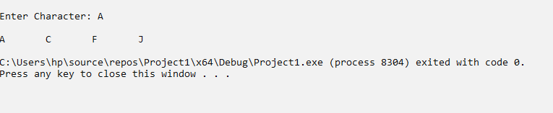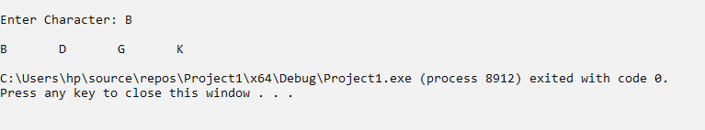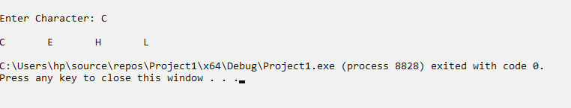

**Post Lab:-**

#include <iostream>

using namespace std;

void main()

{

float C, F;

cout << "\nEnter temperture in Celsius (C): ";

cin >> C;

F = (9.0 / 5.0) * C + 32;

cout << "\nTemperature in Fahrenheit (F): " << F << endl;

}

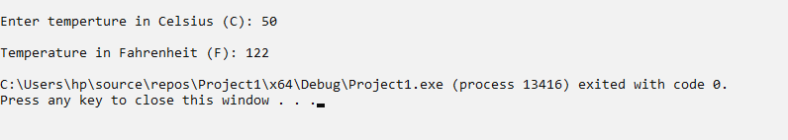

**Issues:-**

No issues were faced during programming.

**Conclusion:-**

* I was able to understand the basic data types and arithmetic operators
* I was able to write simple programs using basic arithmetic operators

**Applications:-**

* Standard arithmetic operators are used to manipulate integrals and floating-point data types.